Table of Contents

1. Introduction………………………………………………………………………………… 2
2. Goals………………………………………………………………………………………… 3
3. Stormwater Discussion…………………………………………………………………..... 4
4. Background…………………………………………………………………………………. 6
5. Water Quality……………………………………………………………………………….. 7
6. Water Quantity……………………………………………………………………………… 8
7. Ground Water Recharge and Wellhead Protection……………………………………. 8
8. Design and Performance Standards…………………………………………………..…. 8
9. Plan Consistency……………………………………………………………………..…….. 9
10. Nonstructural Stormwater Management Strategies………………………………….. 10
11. Mitigation Plus…………………………………………………………………………….. 11

List of Figures

Figure 1: Groundwater Recharge in the Hydrologic Cycle……………………………… 5
Figure 2: Borough Boundary on USGS Quadrangles …………………………. …….. 12
Figure 3: Borough and Its Waterways ……………………………………………………. 13
Figure 4: Hydrologic Units (HUC14s) Within the Borough ……………………………… 14
Figure 5: Borough’s Existing Land Use …………………………………………………… 15
Figure 6: Zoning Districts Within the Borough …………………………………….......... 16
Figure 7: Groundwater Recharge Areas in Borough ………………………….............. 17
Figure 8: Wellhead Protection Areas in the Borough …………………………………… 18

1. Introduction

This Municipal Stormwater Management Plan (MSWMP) documents the strategy for the Borough of Glen Ridge ("the Borough") to address storm⁻water-related impacts. The creation of this plan is required by N.J.A.C. 7:14A-25 Municipal Stormwater Regulations. This plan contains all of the required elements described in N.J.A.C. 7:8 Stormwater Management Rules.

The plan addresses groundwater recharge, stormwater quantity, and stormwater duality impacts by incorporating stormwater design and performance standards for new major development, defined as projects that disturb one or more acre of land. These standards are intended to minimize the adverse impact of stormwater runoff on water quality and water quantity and the loss of groundwater recharge that provides baseflow in receiving water bodies. The plan describes long-term operation and maintenance measures for existing and future stormwater facilities.

The Borough of Glen Ridge is categorized as a Tier A municipality. The Borough is place in the tier A category since it has a population density of 1,000/squre mile and is located in a fully or partially urbanized area. The Borough is exempt from performing a built out analysis since it does not contain one square mile of developable land.

The plan addresses the review and update of existing ordinances, the Borough Master Plan, and other planning documents to allow for project designs that include low impact development techniques. The final component of this plan is a mitigation strategy for when a variance or exemption of the design and performance standards is sought. As part of the mitigation section of the stormwater plan, specific stormwater management measures are identified to lessen the impact of existing development.

2. Goals

The goals of this MSWMP are to:

- Reduce flood damage, including damage to life and property
- Minimize, to the extent practical, any increase in stormwater runoff from any new development,
- Reduce soil erosion from any development or construction project;
- Assure the adequacy of existing and proposed culverts and bridges, and other in-stream structures;
- Maintain groundwater recharge
- Prevent, to the greatest extent feasible, an increase in non point pollution;
- Maintain the integrity of stream channels for their biological functions, as well as for drainage;
- Minimize pollutants in stormwater runoff from new and existing development to restore, enhance, and maintain the chemical, physical, and biological integrity of the water of the state, to protect public health, to safeguard fish and aquatic life and scenic and ecological values, and to enhance the domestic, municipal, recreational, industrial, and other uses of water, and
- Protect public safety through the proper design and operation of stormwater basins.

To achieve these goals, this plan outlines specific stormwater design and performance standards for new development. Additionally, the plan proposes stormwater management controls to address impacts from existing development. Preventative and corrective maintenance strategies are included in the plan to ensure long-term effectiveness of stormwater management facilities. The plan also outlines safety standards for stormwater infrastructure to be implemented to protect public safety.

3. Stormwater Discussion

Land development can dramatically alter the hydrologic cycle (See Figure C-1) of a site and, ultimately, an entire watershed. Prior to development, native vegetation can either directly intercept precipitation or draw that portion that has infiltrated into the ground and return it to the atmosphere through evapotranspiration. Development can remove this beneficial vegetation and replace it with lawn or impervious cover, reducing the site's evapotranspiration and infiltration rates. Clearing and grading a site can remove depressions that store rainfall. Construction activities may also compact the soil and diminish its infiltration ability, resulting in increased volumes and rates of stormwater runoff from the site.

Impervious areas that are connected to each other through gutters, channels, and storm sewers can transport runoff more quickly than natural areas. This shortening of the transport or travel time quickens the rainfall-runoff response of the drainage area, causing flow in downstream waterways to peak faster and higher than natural conditions. These increases can create new and/or aggravate existing downstream flooding and erosion problems and increase the quantity of sediment in the channel. Filtration of runoff and removal of pollutants by surface and channel vegetation is eliminated by storm sewers that discharge runoff directly into a stream. Increases in impervious area can also decrease opportunities for infiltration which, in turn, reduces stream base flow and groundwater recharge. Reduced base flows and increased peak flows produce greater fluctuations between normal and storm flow rates, which can increase channel erosion. Reduced base flows can also negatively impact the hydrology of adjacent wetlands and the health of biological communities that depend on base flows. Finally, erosion and sedimentation can destroy habitat from which some species cannot adapt.

In addition to increases in runoff peaks, volumes, and loss of groundwater recharge, land development often results in the accumulation of pollutants on the land surface that runoff can mobilize and transport to streams. New impervious surfaces and cleared areas created by development can accumulate a variety of pollutants from the atmosphere, fertilizers, animal wastes, and leakage and wear from vehicles. Pollutants can include metals, suspended solids, hydrocarbons; pathogens, and nutrients.

Land development can adversely affect water quality and stream biota in more subtle ways. For example, stormwater falling on impervious surfaces or stored in detention or retention basins can become heated and raise the temperature of the downstream waterway, adversely affecting cold water fish species such as trout, Development can remove trees along stream banks that normally provide shading, stabilization, and leaf litter that falls into streams and becomes food for the aquatic community.

Figure 1: Groundwater Recharge in the Hydrologic Cycle

Source: New Jersey Geological Survey Report GSR-32.

4. Background

The Borough encompasses 1.4 square mile (1,024 acres) area in Essex County, New Jersey. It is 12 miles west of New York City and 7 miles west of Newark. Figure -2 depicts the Borough’s boundary on the USGS quadrangle map.

The Borough of Glen Ridge is a developed suburban community that after rapid growth in the first part of the twentieth century reached its peak population of 8,518 in 1970. Overall, the population for the Borough has remained fairly consistent. In 1980 and 1990 the Borough experience two periods of slight decline a 633 and a 779 person decline respectively. The 2000 census shows a slight increase of 195 persons.

This population shift mirrors Essex County that also has experienced the same shifts in populations.

There are 2,490 housing units in Glen Ridge. The majority of the housing stock of the Borough of Glen Ridge consists of single-family detached housing. There were 2,101 single-family detached homes in 2000, which represents approximately 85 percent of the total housing stock. Single-family attached consisted of 18 units or about 0.7 percent. The remainder of the units was condominiums or apartments; there were no mobile home or trailer units in the Borough.

Glen Ridge is within the drainage basin of the Passaic River. A minor stream, Toney Brook bisects the Borough. A small section of the south west portion of the Borough drains to the Nishuane Stream in Montclair. Both streams are tributaries to the Second River. The majority of the northern section of the Borough as well as the eastern half of the south end drains to the Third River in Bloomfield. Figure - 3 and Figure - 6 illustrates the waterways in the Borough.

The Borough is fully built out in that there is no large lots or tracts available. The only developable land available is the Glen Ridge Country Club which contains approximately 12 acres of vacant land. All other open space is deed restricted for either conservation or recreation.

The nature of new development consists of expansion of existing residential structures, addition of accessory structures and patios, and occasionally, the redevelopment of commercial/industrial structures or the demolition of existing residence to allow for the construction of new, larger home.

5. Water Quality

The New Jersey Department of Environmental Protection (NJDEP) has established an Ambient Biomonitoring Network (AMNET) to document the health of the state's waterways. There are over 800 AMNET sites throughout the state of New Jersey. These sites are sampled for benthic macroinvertebrates by NJDEP on a five-year cycle. Streams are classified as non-impaired, moderately impaired, or severely impaired based on the AMNET data. The data is used to generate a New Jersey Impairment Score (NJIS), which is based on a number of biometrics related to benthic macroinvertebrate community dynamics respectively; are both moderately impaired. There are no AMNET monitoring sites within the Borough.

In addition to AMNET data, the NJDEP and other regulatory agencies collect water quality chemical on the streams in the state. One measure is the Total Maximum Daily loads (TMDL) for pollutants. A TMDL is the amount of a pollutant that can be accepted by a water body without causing an exceedance of water quality standards or interfering with the ability to use a water body for one or more of its designated uses. The allowable load is allocated to the various sources of the pollutant, such as stormwater and wastewater discharges, which require an NJPDES permit to discharge, and nonpoint source, which includes stormwater runoff from agricultural areas and residential areas, along with a margin of safety. Provisions may also be made for future sources in the form of reserve capacity. An implementation plan is developed to identify how the various sources will be reduced to the designated allocations. Implementation strategies may include improved stormwater treatment plants, adoption of ordinances, reforestation of stream corridors, retrofitting stormwater systems, and other Best Management Practices (BMPs).

The NJDEP has not designated any TMDL limits for the Borough’s only stream, Toney’s Brook .

The Borough of Glen Ridge is not within a Special Water Resource Protection Area (SWRPA) as it does not contain any Category One waters or tributaries to any Category One waters. The NJDEP is designating a special level of protection for a number of waterways in New Jersey. This protection, known as Category One, targets water bodies that provide drinking water, habitat for Endangered and Threatened species, and popular recreational and/or commercial species, such as trout or shellfish. Waterways can be designated Category One because of exceptional ecological significance, exceptional water supply significance, exceptional recreational significance, exceptional shellfish resource, or exceptional fisheries resource. The Category One designation provides additional protections to water bodies that help prevent water quality degradation and discourage development where it would impair or destroy natural resources and environmental quality. Stormwater Management Rules do not require a buffer for waters other than Category One; however, Borough waters are still subject to Flood Hazard Control Rules, which require a 25’ buffer on all streams (stream encroachment). This permit is obtained by the applicant from the NJDEP.

The Borough has less than one square mile of vacant land available for development; therefore, a build out analysis is not required as part of this MSWMP. Figure 4 shows the location of HUC 14s in the Borough.

6. Water Quantity

In addition to water quality problems, the Borough has exhibited severe water quantity problems including flooding and stream bank erosion. Some of the storm sewer system in the Borough is undersized thereby causing a backwater effect and flooding during severe storms. During Tropical Storm Floyd the rainfall amounts exceeded the 100-year design storm causing flood damage in certain areas especially along Toney’s Brook from Hillside Avenue to the Borough’s boundary with the Township of Bloomfield.

Since it is not economically feasible to provide 100 year flood structural protection, the Borough’s goal should be to provide flood protection against the more frequent, low magnitude storm events were possible. Smaller storms events often trigger flooding due to stream obstructions, insufficient capacity of some bridges and inadequate storm pipe capacity.

7. Recharge and Well Head Protection

The Borough is essentially fully developed as shown in Figure 5 - Land Use Map. Figure 6 is the current Borough Zoning Map, which indicates that the majority of land within the municipality is zoned for residential, mainly single family homes. The high imperviousness of the Borough has significantly decreased ground water recharge. Research has shown the amount of impervious surface in a watershed to be a reliable indicator of the impacts on water resources. Figure 7 - Ground Water Recharge Areas shows the rates of recharge throughout the Borough. Supporting calculations are contained in the appendix.

Wellhead protection areas, as well as well locations, also required as part of the MSWMP, are shown on Figure - 8.

8. Design and Performance Standards

The Borough will adopt the design and performance standards for stormwater management measures as presented in N J.A.C. 7:8-5 to minimize the adverse impact of stormwater runoff on water quality and water quantity and loss of groundwater recharge in receiving water bodies. The design and performance standards include the language for maintenance of stormwater management measures consistent with the. Stormwater management rules at N.J.A.C. 7:8-p.8 Maintenance Requirements, and language for safety standards consistent with N.J.A.C. 7:8-6 Safety Standards for Storm-water Management Basins. The ordinances will be submitted to the county for review and approval within 24 months of the effective date of the Stormwater Management Rules.

The Stormwater Management Ordinance will be submitted to Essex County for review and approval by April 15, 2006.

During construction, Borough inspectors will observe the construction of the project to ensure that the stormwater management measures are constructed and function as designed.

9. Plan Consistency

The Borough is not within a Regional Stormwater Management Planning Area and no TMDLs have been developed for waters within the Borough; therefore this plan does not need to be consistent with any regional stormwater management plans (RSWMPs) or any TMDLs. If any RSWMPs or TMDLs are developed in the future, this Municipal Stormwater Management Plan will be updated to be consistent.

The Municipal Stormwater Management Plan is consistent with the Residential Site Improvement Standards (RSIS) at N.JA.C. 5:21. The municipality will utilize the most current update of the RSIS in the stormwater management review of residential areas. This Municipal Stormwater Management Plan will be updated to be consistent with any future updates to the RSIS.

The Borough's Stormwater Management Ordinance requires all new development and redevelopment plans to comply with New Jersey's Soil Erosion and Sediment Control Standards. During construction, Borough inspectors will observe on-site soil erosion and sediment control measures and report any inconsistencies to the local Soil Conservation District.

10. Nonstructural Stormwater Management Strategies

The Borough has reviewed the master plan and ordinances, and has provided a list of the sections in the Borough land use and zoning ordinances that are under consideration to be modified to incorporate nonstructural stormwater management strategies. These are the ordinances identified for revision. Once the ordinance texts are completed, they will be submitted to the county review agency for review and approval within 24 months of the effective date of the Stormwater Management Rules. A copy will be sent to the Department of Environmental Protection at the time of submission.

CHAPTER 16.24 - Subdivision & Site Plan Review

16.24.110.15 Soil Erosion and Sediment Control addresses soil erosion and sediment control by referencing N.J.S.A. 4:24-39 et. Seq.. This section requires developers to comply with the New Jersey Soil Erosion and Sediment Control Standards. It will be amended to outline some general design principles, including whenever possible, retain and protect natural vegetation; minimize and retain water runoff to facilitate groundwater recharge; and, install diversions, sediment basins, and similar required structures prior to any on-site grading or disturbance.

16.24.120.1 Applicable Standards Specifications. This section requires gutters requires that concrete curb and gutter, concrete curb, or Belgian block curb be installed along every street within and fronting on a development. This section will be reviewed to allow for curb cuts or flush curbs with curb stops to allow vegetated swales to be used for stormwater conveyance and to allow the disconnection of impervious areas.

16.24.120.8.B1. This section mandates that all off-street parking areas for nonresidential uses permitted in residential zones, and all off-street parking areas in nonresidential zones and for transitional lots shall have a minimum four-inch thick macadam base course and a two-inch thick bituminous concrete surface course. This section will be amended to allow the use of pervious paving materials to minimize stormwater runoff and promote groundwater recharge.

16.24.120.11.B .9. This section states sidewalks shall be constructed on the site to adequately serve pedestrian traffic as required by the planning board. Language will be added to this section to require developers to design sidewalks to discharge storm⁻water to neighboring lawns where feasible to disconnect these impervious surfaces, or use permeable paving materials where appropriate.

16:24.130.14: This section requires that natural features, such as trees, brooks, swamps, hilltops, and views, be preserved whenever possible, and that care be taken to preserve selected trees to enhance soil stability and landscaped treatment of the area. This section will be amended to expand trees to forested areas, to ensure that leaf litter and other beneficial aspects of the forest are maintained in addition to the trees.

The Borough is evaluating performance standards to provide pollution source control. It will prohibit materials or wastes to be deposited upon a lot in such form or manner that they can be transferred off the lot, directly or indirectly, by natural forces such as precipitation, evaporation or wind. It also requires that all materials and wastes that might create a pollutant or a hazard be enclosed in appropriate containers.
The Borough is evaluating the maximum allowable impervious cover for each zone to determine whether a reduction in impervious cover is appropriate. Also under consideration is a variance process. If a developer is given a variance to exceed the maximum allowable percent imperviousness, the developer must mitigate the impact of the additional impervious surfaces. This mitigation effort must address water quality, flooding, and groundwater recharge.

11. Mitigation Plans

Mitigation Project Criteria
The mitigation project must be implemented in the same drainage area as the proposed development. The project must provide additional groundwater recharge benefits, or protection from stormwater runoff quality and quantity from previously developed property that does not currently meet the design and performance standards outlined in the Municipal Stormwater Management Plan. The developer must ensure the long-term maintenance of the project, including the maintenance requirements under Chapters 8 and 9 of the NJDEP Stormwater BMP Manual.

The applicant can select one of the following projects listed to compensate for the deficit from the performance standards resulting from the proposed project. More detailed information on the projects can be obtained from the Borough Engineer. Listed below are specific projects that can be used to address the mitigation requirement.

Retrofit the existing parking areas and driveways at the Hillside Parking Lot to provide the removal of 80% of the total suspended solids. The retrofit must not reduce the utility of the parking areas in any way.

Retrofit the existing parking areas and driveways at the Benson Street Parking Lot to provide the removal of 80% of the total suspended solids. The retrofit must not reduce the utility of the parking areas in any way.

Retrofit the existing parking areas and driveways at the Glen Ridge High School Parking Lot to provide the removal of 80% of the total suspended solids. The retrofit must not compromise the utility of the parking areas in any way.

Retrofit the existing parking areas and driveways at the Forest Avenue School Parking Lot to provide the removal of 80% of the total suspended solids. The retrofit must not reduce recreational use of the outdoor space at the site or compromise the utility of the parking areas in any way.

Retrofit the existing parking areas and driveways at the Linden Avenue School Parking Lot to provide the removal of 80% of the total suspended solids. The retrofit must not reduce recreational use of the outdoor space at the site or compromise the utility of the parking areas in any way.

Retrofit the existing parking areas and driveways at the Ridgewood Avenue School Parking Lot to provide the removal of 80% of the total suspended solids. The retrofit must not reduce recreational use of the outdoor space at the site or compromise the utility of the parking areas in any way.

Figure 2: Borough’s Boundary on the USGS Quadrangle Map

Figure 3: Borough and Its Waterways

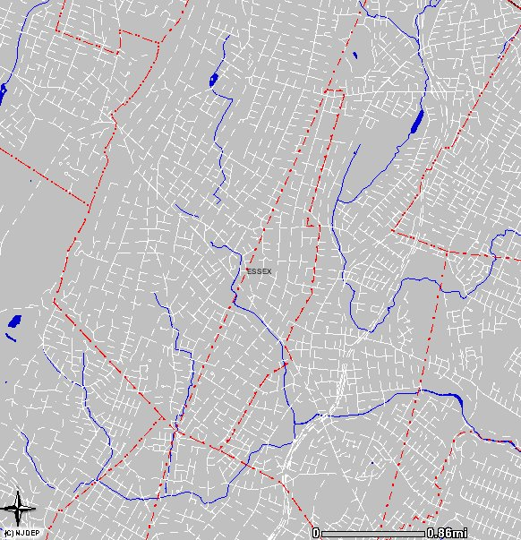

Figure 4: Hydrologic Units (HUC14s) Within the Borough

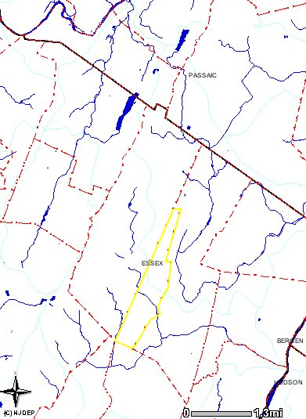

Huc14
Figure 5: Borough's Existing Land Use

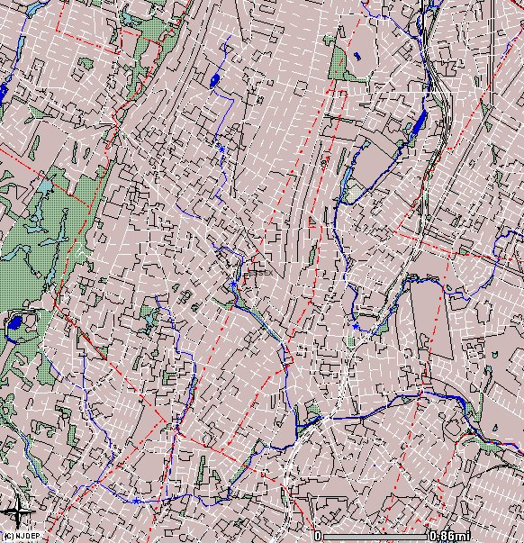
Land Use

Parks & Green Space – 3.88%
Developed Land – 96.1%
Water – 0.2%

Figure 6: Zoning Districts Within the Borough

Figure 7 Recharge Area Map for Glen Ridge Borough 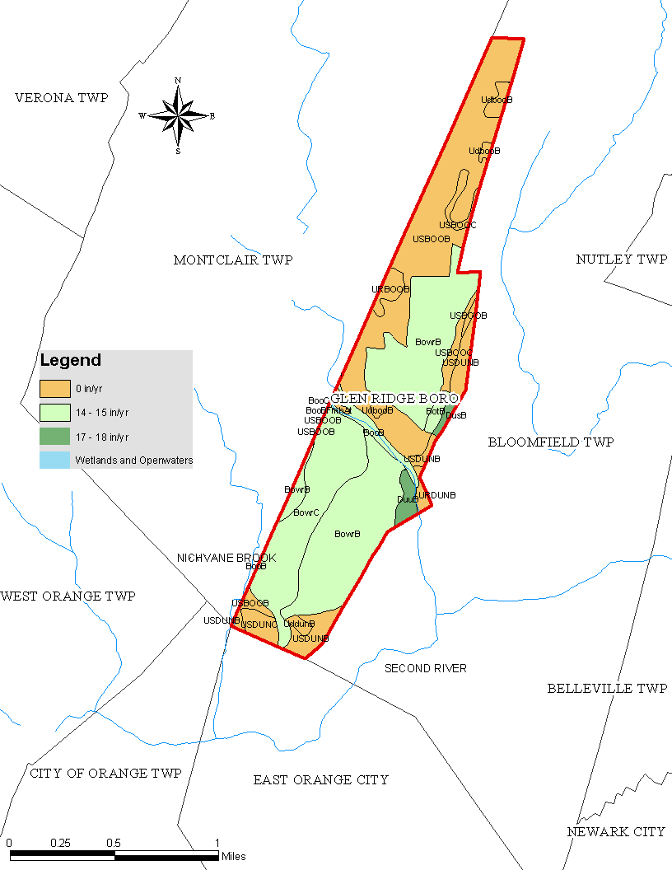
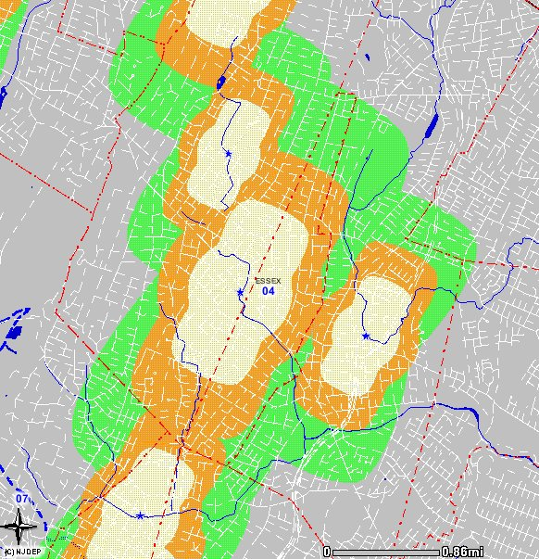
Figure 8: Wellhead Protection Areas in the Borough

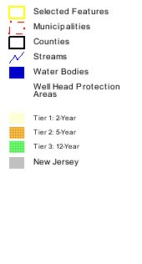

APPENDICES

