Glen Ridge PD Video Solutions
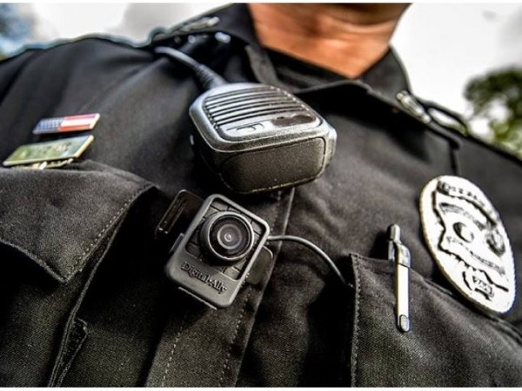
The Glen Ridge Police Department is excited to announce we have implemented the Digital Ally FirstVu HD body camera. It is the most versatile and easy to use body camera on the market today. The body camera can be automatically activated or manually activated by the officer pressing the record button on the camera module. The FirstVu HD has HD audio/video quality and wide field of view, so it is able to capture exactly what the officer sees during an incident. This camera is small and lightweight, but also tough enough to withstand our extreme cold and hot temperatures.
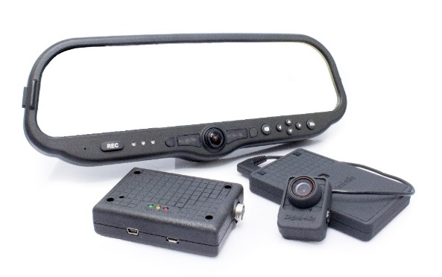
Along with the body cameras, we have also implemented the Digital Ally DVM-800 in-car video system, and their VuLink technology. The VuLink fully integrates the in-car cameras with the body worn video. This allows our officers to automatically and simultaneously activate their dash cameras, wireless microphones and body cameras by the use of multiple triggers, including G-Force sensors, the light bar, vehicle speed, and more. The dash camera and body camera footage is linked and seamlessly integrated into our back-office software. This allows our officers to focus on their job and not the video, thus keeping themselves and our entire community safer!

