May | 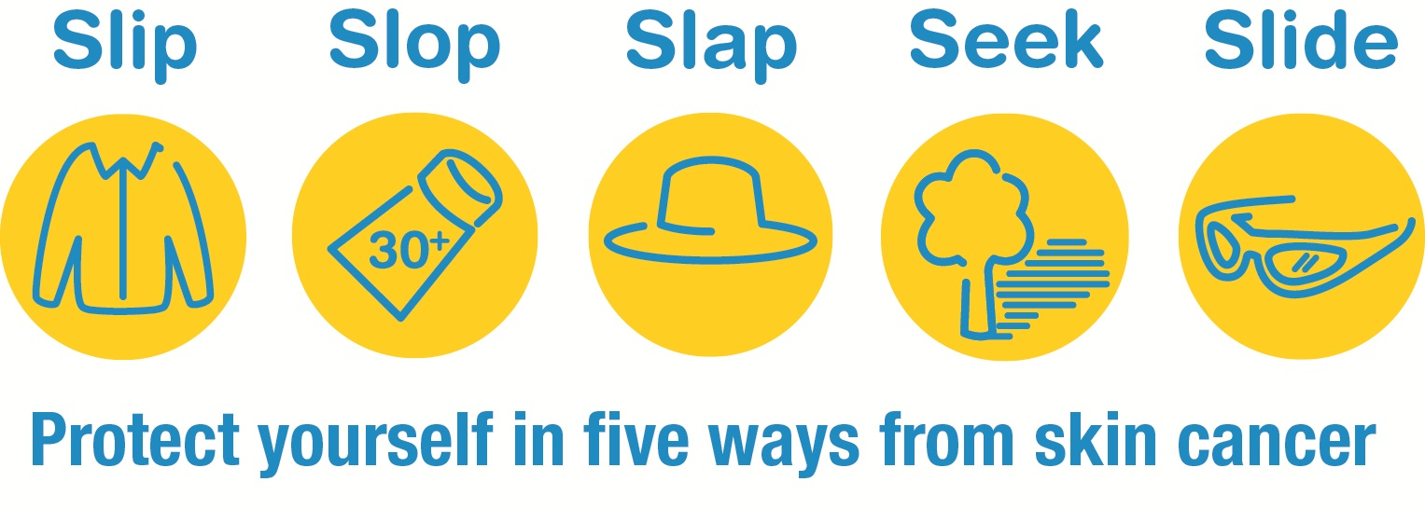
 | 2018

Melanoma/Skin Cancer Detection and Prevention
Sunday | Monday | Tuesday | Wednesday | Thursday | Friday | Saturday
 |  | 1 | 2 | 3 | 4 | 5
 |  | May is Melanoma/Skin Cancer Detection and Prevention Month! Take these steps to protect yourself from #SkinCancer: http://1.usa.gov/1G8qOTW. |  | #DYK? #SkinCancer is the most common type of cancer in the U.S. Learn more: http://1.usa.gov/1AZDGpd. |  | Ultraviolet (UV) radiation from the sun is the main cause of #SkinCancer. Learn more: http://bit.ly/2mxjLDq
6 | 7 | 8 | 9 | 10 | 11 | 12
 | UV damage can also cause wrinkles and blotches or spots on your skin |  | Skin cancer affects people of all ages, including older adults. Get the facts: http://1.usa.gov/jt7vYY |  | You can protect yourself from #SkinCancer by doing regular skin self-exams. Learn how: http://1.usa.gov/1nZSlRU
13 | 14 | 15 | 16 | 17 | 18 | 19
 |  | Health Tip: Put sunscreen on 30 minutes before you go outside to help prevent #SkinCancer. For more tips: http://bit.ly/1Vc9PJt |  | Be cool and wear your shades – UV rays can hurt your eyes. Get more tips to keep your eyes healthy: http://bit.ly/1zNmQ1e |  | Use sunscreen with SPF 15 or higher.  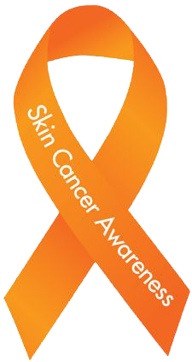  Put on sunscreen every 2 hours and after you swim or sweat.
20 | 21 | 22 | 23 | 24 | 25 | 26
 |  |  | Stay out of the sun as much as possible between 10 a.m. and 4 p.m.
27 | 28 | 29 | 30 | 31
 |  | 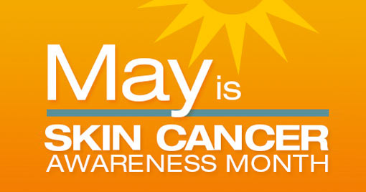
For more information visit https://www.skincancer.org/

