February
Glen Ridge Borough Health Department  Phone: 973-680-4024  Fax: 973-680-4825  health@bloomfieldtwpnj.com | 2018

American Heart Month
Sunday | Monday | Tuesday | Wednesday | Thursday | Friday | Saturday
 |  |  |  | 1 | 2 | 3
 |  |  |  | It’s #AmericanHeartMonth! Find out what you can do today to lower your risk for heart disease | It’s National Wear Red Day!
4 | 5 | 6 | 7 | 8 | 9 | 10
 | #DYK? Heart disease is the leading cause of death for both men and women in the U.S. |  | About 600,000 Americans die from heart disease every year—that's 1 of every 4 deaths. |  | Having high blood pressure, having high cholesterol, and smoking tobacco all increase your risk for heart disease
11 | 12 | 13 | 14 | 15 | 16 | 17
 |  | High blood pressure is a common cause of heart disease and stroke, so it’s important to check your blood pressure. |  | It’s important to get your blood pressure checked regularly starting at age 18
18 | 19 | 20 | 21 | 22 | 23 | 24
 | You have the power to prevent heart disease & stroke. The first step? Talk to your doctor |  | Take small steps toward preventing heart disease & stroke, like eating better & exercising. Little things do add up! |  | Planning a grocery store trip this weekend? Pump up your heart health by choosing foods that are low in sodium (salt)
25 | 26 | 27 | 28
 |  |  |  |  | 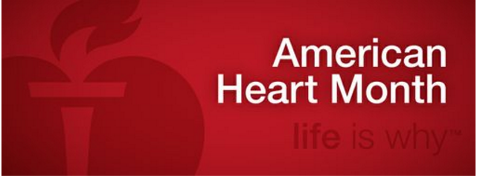
For more information on Heart Disease please visit http://www.heart.org/HEARTORG/ https://www.goredforwomen.org/

