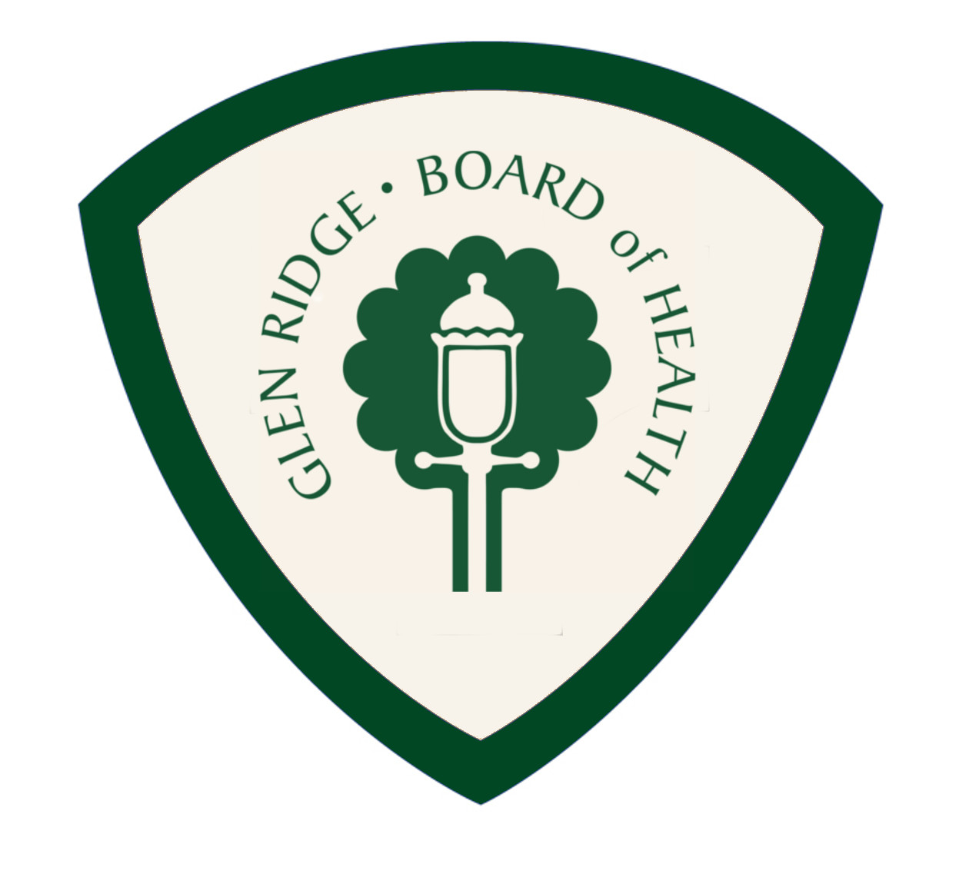
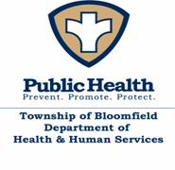
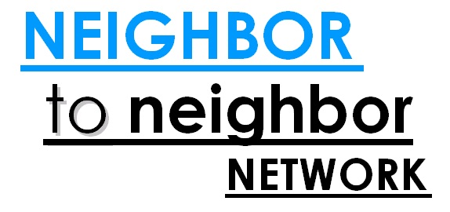

October 25, 2014
Dear Resident,
You may have previously registered yourself or a member of your family with our Emergency Outreach program in order for the Borough to assist you during times of emergency. If you have not previously registered, you now have the opportunity to register. The State of New Jersey Office of Emergency Management has begun a confidential web-based program to identify those individuals that may need assistance in the event of an emergency called New Jersey Register Ready. The Borough will be transferring our Emergency Outreach Program into the State program now that it is available unless you inform us that you do not wish to share your information. Your information will become part of a more complete database with a more efficient method of contact and response during an event.
The Borough of Glen Ridge will be working collaboratively with Bloomfield Human Services and The Neighbor to Neighbor Network on this program. You may also go to the website www.registerready.nj.gov yourself or have someone help you complete the form online. Certain Health Department personnel have access to all information that is entered into this system through password protection and HIPPA requirements.
For individuals without internet access, you may contact 211 or Bloomfield Human Services at (973) 680-4017 for assistance.

