

Beginning January 1st, 2018, participating taxi companies will provide seniors 62+ a 50% discount.

•••

**PROOF OF AGE REQUIRED**

**Participating Taxi Companies:**

Good Taxi (609)-922-5179

Le Rubicon Taxi (201)-463-8344

M&M Taxi (973)-746-7575

**Just ask for the senior** **discount when you schedule your ride!**

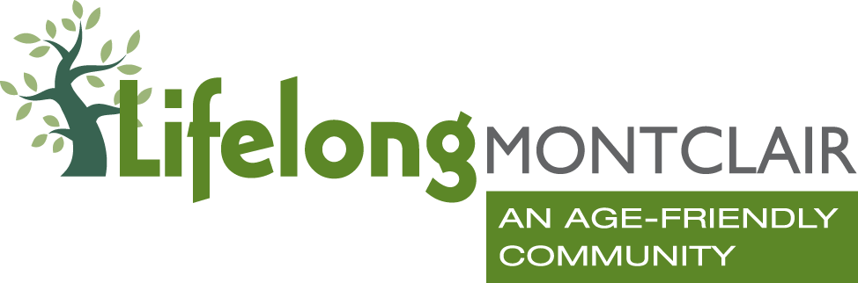

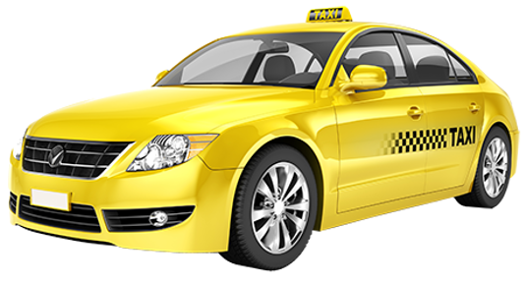

Questions or concerns? Please call the taxi company first.   
If your issue is not resolved, call 973-744-3278.